FETAL MONITORING
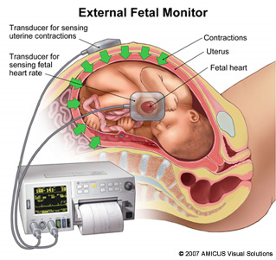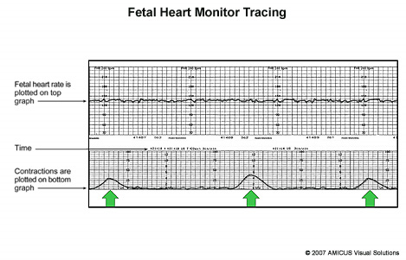
www.fetalmonitorstrips.com/learn_more.htm
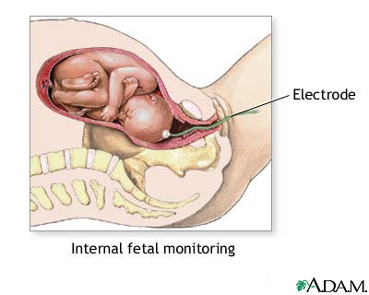
http://medicalimages.allrefer.com/large/internal-fetal-monitoring.jpg

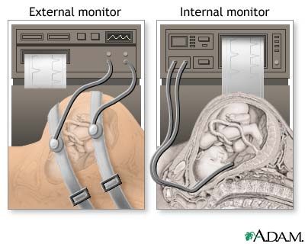
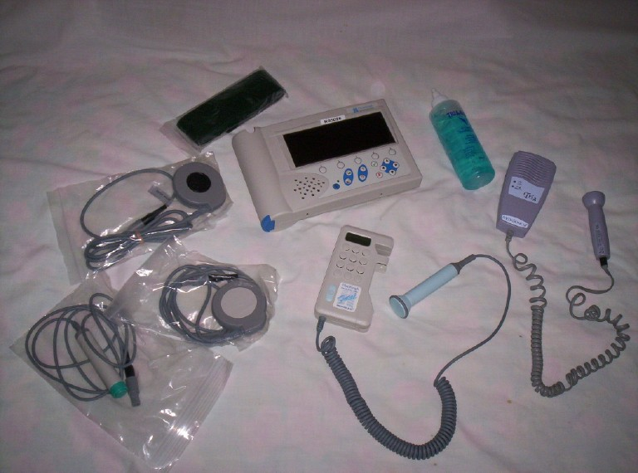


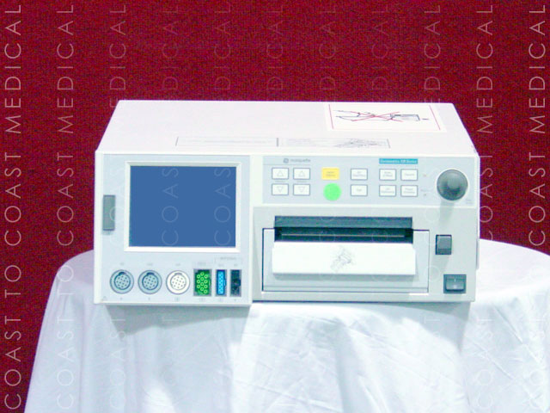+
GE / Corometrics 120 Series Fetal Monitors | Email Us About This Product
• Available Models : 115, 116, 118, 120, 126, 128, 129, 145, 150, 151, 170 (505 Neonatal)
• Spectra Alerts Analysis Software Option
• Keyboard Option for Detailed Annotations
• Software Utility Upgrade Program
• Sweetheart Recorder for Real-time MECG Printing
• Interface with 340 Telemetry for Ambulatory Monitoring and Hydrotherapy
• Interface Capability with the Oxifirst® Fetal Pulse Oximetry System
www.coast2coastmedical.com/monitors_fetal.htm

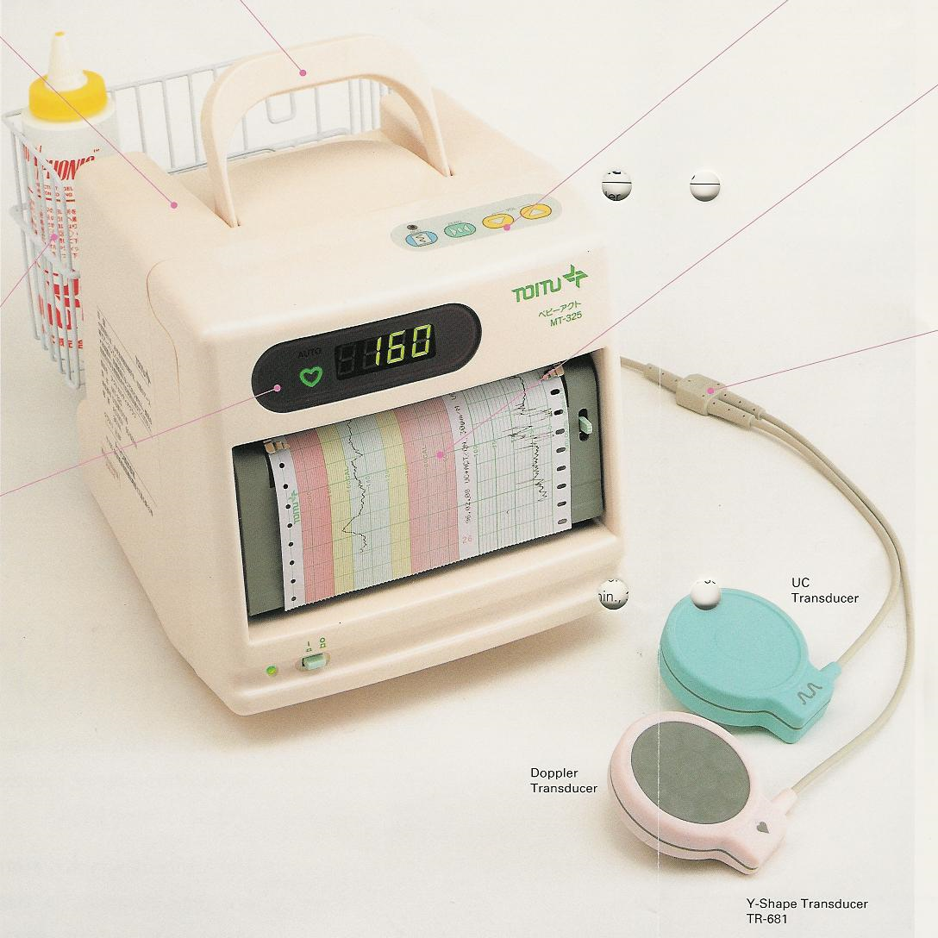
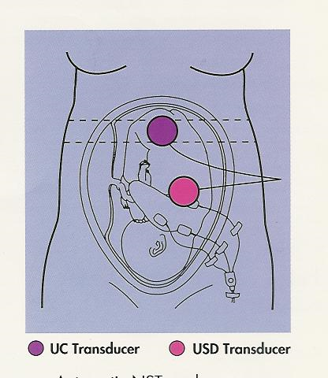
- Automatic NST Mode
- Automatic detection and recording of fetal movement
- Audible and visual FHR alarms
- Y-shaped cable
- Extremely compact and lightweight

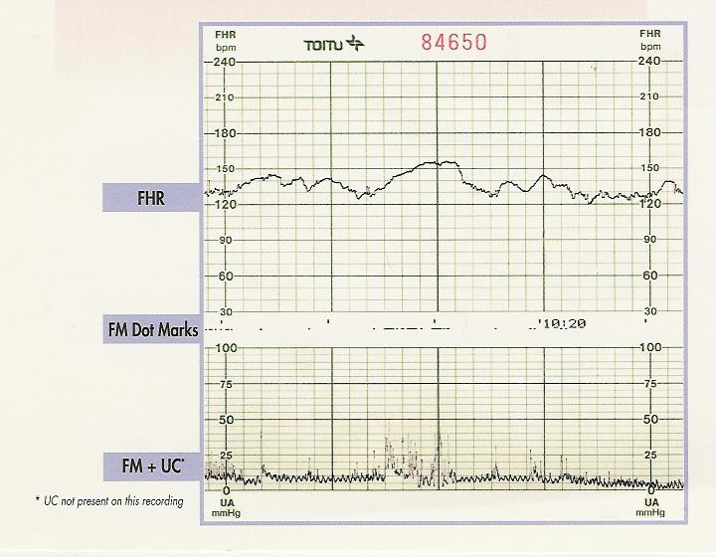
MT-325 Specifications
Fetal Heart Rate (FHR)
Output Signal
Ultrasound Pulsed Doppler, 1.1 MHz
Ultrasound Wave Intensity ≤ 1.5 mW/cm²
Detection Method
Ultrasound Pulsed Doppler (FHR and Fetal
Movement
Measurement
Method - "Instantaneous" Autocorrelation
Range - 50-212 beats per minute (BPM)
Accuracy - 0.5%
Calibration Point Factory set
Display
FHR - Numeric 50-212 PBM
Heartbeat Rhythm - Heart symbol color changes
with signal quality
Heartbeat Sound Monitoring
Original sound via doppler
Alarms
Selectable FHR upper and lower limits
Selectable alarm delay setting
Tachycardia and Bradycardia audible alarms are
distinctive and simultaneous with visual FHR
display that turns red and blinks.
Fetal Movement (FM)
Detection Source
Ultrasound Pulsed Doppler
Recording
Spike waveform on uterine contraction channel
denotes relative intensity and duration of FM
and/or
Dot marks between FHR and uterine contraction
channels when FM intensity exceeds selected
threshold
Uterine Contraction (UC)
Input Source
Esternal tocodynamometer
Differential amplifier
Frequency response from DC to 0.5 Hz
One-touch zero-level button
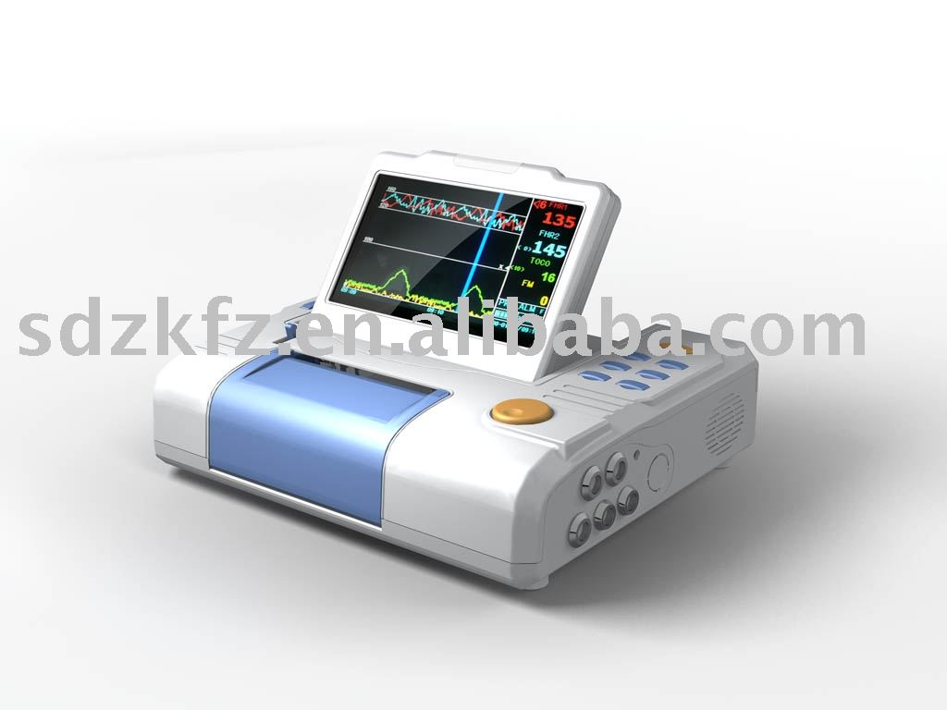
www.sdzkfz.en.alibaba.com
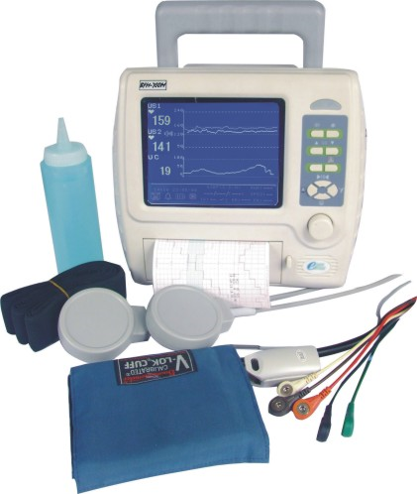
www.made-in-china.com/showroom/szbestman/prod...
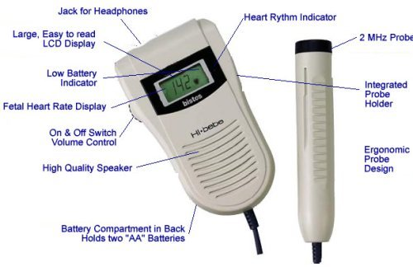
http://ucables.com/ref/HI-BEBE-HEART-RATE-MO-R64251
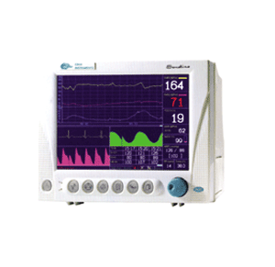 CMS 9000F Maternal/Fetal Monitor
CMS9000F Maternal /Fetal Monitor Technical Data
CMS9000F Maternal /Fetal Monitor, designed for the applicaion in theantepartum , intrapartum and postpartum applications.
CMS9000F is suitable for private obstetrician office, antepartum clinic, moving situation or home monitoring situation. It offers most advanced integrated monitoring of fetus and mother .
Option
Twins monitoring capability
Thermal printer or inkjet printer

Features
■ Support external thermal printer or inkJet printer
■ Built-in rechargeable battery, DC/AC power supply
■ Built-in network capability
■ Large color TFT screen display waveforms and digitals
■ Maternal Parameters: ECG, SPO2, NIBP, RESP, TEMP
■ Automatic Fetal Movement Detection, AFM waveform display
■ 24 hours monitoring data storage and reload
■ Acceleration and Deceleration measurement ability
■ Baseline, acceleration and deceleration analysis capability
■ Easy operation by with shortcut key and rotary knob
■ Super printing functions
■ Automatic monitoring mode, parameters configurable
■ Clinical data management , can be reload, reanalysis, reprint
■ Visual and audio alarm, comply with international standard
http://www.contecmed.com/paypal/product1.asp?id=Fetal%20Monitor
Introduction CMS-VE Visual Electronic Stethoscope Features Portable and convenient to operate based on latest piezo sensor
Visual Electronic Stethoscope
■ Portable and convenient to operate
■ based on latest piezo sensor technology
■ Powerful electronics amplify the sound up to a maximum of 32 times

■ 16 steps programmable volume settings

■ Sound model: Heart, Lung, Heart and Lung

■ Frequency Response: 20Hz - 20,000Hz

■ Real-time record and display the heart rate and ECG

■ Profesional spo2 dispaly with adult and neonatle probe(option)

■ TFT color LCD display (65536 color): 160*128 pixels

■ Accommodates infant, pediatric, and adult patients

■ 4.2V Rechargeble Lithium battery

■ Automatic switch off after 3 minutes from last button activation

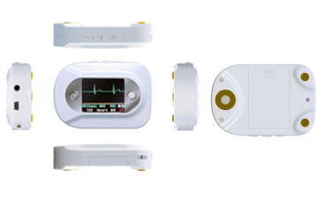http://www.contecmed.com/paypal/product_show.asp?id=34

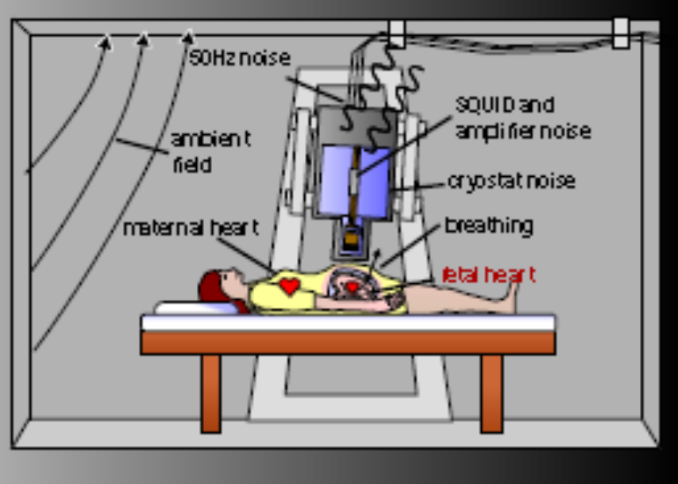

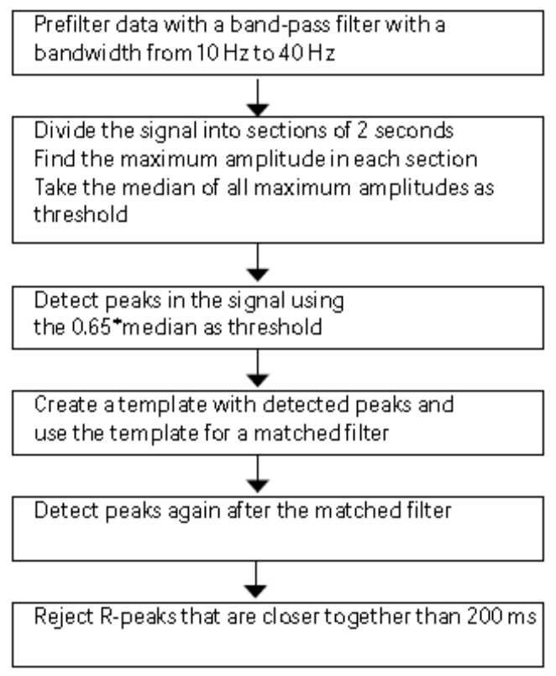

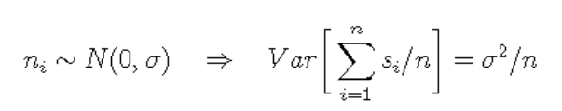

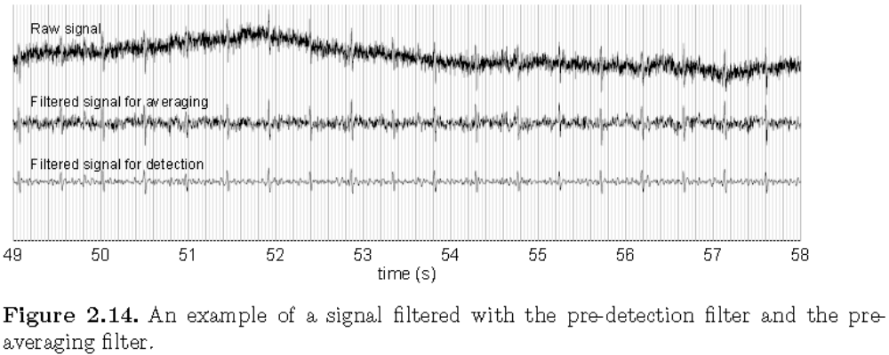
10-40Hz BandPass
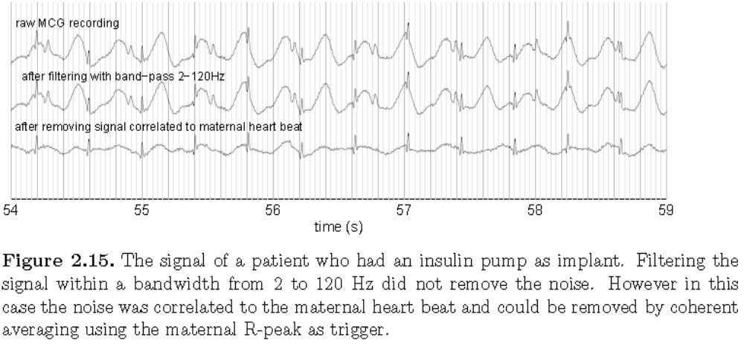
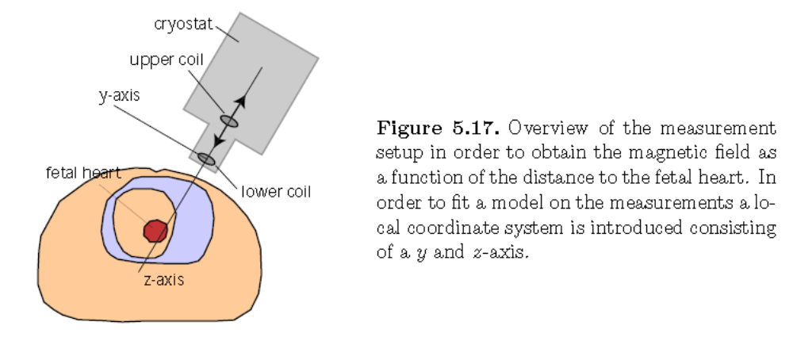Jeroen Gustaaf Stinstra: RELIABILITY OF THE FETAL MAGNETOCARDIOGRAM PhD értekezés

